E-Pharmacy Business Plan

Name
Institution
Course
Instructor
Date

E-Pharmacy Business Plan
Introduction
Name of Proposed Business
The proposed name for this business is an E-Pharmacy, which will enable people to purchase medical supplements, prescription drugs, and other drugs online without necessarily visiting the pharmacy physically.
Name of Principals
The principals comprised of a board of directors are Adams J. Joseph, an instituting member of 4 different start-ups with proven experience in the pharmacy industry in business growth, employee management, and business development structures. He holds an MBA from the University of Pennsylvania and has access to a network of a financial and social network. The second principle goes by the name Glidden Jason. His experience is in the development of management plans and corporate marketing for multi-regional chain pharmacies. He has trained, organized, and managed numerous pharmacies in different locations across the country.
Additionally, he holds an MBA from the University of Florida and has access to a financial and social capital network. The final principle in our board of directors is Mr. Jurenka David. He is a licensed pharmacist and has a proven track record of running numerous pharmacies across the country successfully. He has a warm relationship with pharmacists and holds a degree in pharmacology from the University of Montana. He also has access to capital.
Nature of Proposed Business
The nature of this business is selling prescription medications and other products at the retail level to consumers on the online platform. Similarly, the business is looking to deliver orders to clients' doorsteps or their preferred locations, conveniently helping them save costs such as transport costs. Therefore, this business aims to deliver orders within the shortest time possible. We know that some individuals among our local population depend on medication to live, and timely delivery can sometimes save lives.
Statement of Financial Need
On the contrary, the initial capital required for this start-up is $1,215,745, which will be used in purchasing and setting up the essential infrastructure and covering all the initial expenses.
Confidentiality Statement
Protected Medical Information (PMI) – which comprises patient financial and medical information, employee and student information, E-Pharmacy financial and operating data, and any other private or sensitive information – is considered confidential. Employees should not view or disclose confidential information unless relevant to their specific job responsibilities (Prashanti et al., 2017).
Executive Summary
E-Pharmacy will predominantly exist in the online space; the business will have an E-Commerce platform and a phone application to provide clients with the ease of making orders at the comfort of their homes or any other place they would wish to. In addition, the business will also employ the LOTS dispensing software in its operations, which provides an electronic transfer of prescriptions, making it easier to track orders and prescriptions (Alwon et al., 2015). Similarly, the software will be used in staff and consignment management because these features are present in the system. The form of E-Pharmacy will be a general partnership with the three entrepreneurs being the majority shareholders. This form of ownership will allow the benefits of shared resources, which will provide more business capital and the fact that each partner will share the total profits of the organization. Also, the products will be offered at highly competitive costs compared to what is available in the current market. The products will be distributed in two ways. The first will be through the online platforms, the website, and mobile application, and get their orders delivered at their doorstep. E-Pharmacy will also allow customers to purchase prescriptions, over-the-counter medications, and durable medical supplies on-site at our physical outlet.
On the contrary, Adams J. Joseph, an original member of four distinct start-ups with demonstrated experience in the pharmaceutical industry in business growth, staff management, and business development structures, will serve E-Pharmacy's board of directors. He has an MBA from the University of Pennsylvania and has connections in the financial and social worlds. Glidden Jason is the name of the second principal. His background includes creating management plans and corporate marketing for multi-regional pharmacy chains. He has worked at various pharmacies across the country, training, organizing, and managing them. He also possesses an MBA from the University of Florida and has access to a network of financial and social resources. Mr. Jurenka David is the final member of our board of directors. He is a qualified pharmacist with a track record of effectively managing multiple pharmacies across the country. David has a good working connection with pharmacists and has a pharmacology degree from the University of Montana. He also has financial resources.
The E-pharmacy will offer a wide range of over-the-counter pharmaceuticals and front-shop products, including prescription drugs, medical supplements, allergy treatment, Diabetes strips, syringes, meters, and family planning to meet all healthcare needs. Skincare goods, cough and cold drugs, acid reflux and stomach medications, diet, nutrition, and meal supplements will also be available. E-Pharmacy will provide first aid, home medical, personal hygiene, and patient counseling, among other services. E-Pharmacy will also provide drug disposal, compliance, and blister packaging services. Because the bulk of the targeted population is senior, the target segment will be determined by their age demography. As a result, they will be the most beneficiaries of the delivery services.
Similarly, we want to help the most vulnerable community members who may not get to a pharmacy to get prescription medication. Also, certified drug makers would be the company's primary source of supplies. Because the product marketing base would be critical, e-pharmacy would ensure good prospects in the drug supply industry. Before choosing a supplier, the corporation would ensure that all legislative and regulatory standards for ensuring the authenticity of drugs are met. As a result, E-Pharmacy will only accept items from companies that have met the CGMPs (Good Manufacturing Practices) requirement for human pharmaceuticals (Van Der Nat et al., 2021).
Industry Analysis
Future Outlook and Trends
The retail pharmacy business is worth $230 billion. As the overall population grows older, this number climbs each year. Chain stores, marketplaces, mass merchandisers, mail-order pharmacies, and individual pharmacies make up this extremely fragmented industry. This sector is predicted to increase at a rate of 5% each year. This increase can be ascribed to rising population age, increased pharmaceutical company marketing, and the introduction of new pharmaceuticals to the market. Based on dynamic market forces and progression-promoting factors, reports estimate industry growth and market worth. In North America, the e-Pharmacy platform is the most notable leading market. The United States has the highest internet penetration due to the well-developed infrastructure of IT corporations. Because most surgeries are performed at home, the COVID-19 epidemic has increased demand for the e-platform.
Analysis of Competitors
Likewise, the industry's key competitors are geographically located within proximity of our targeted community with an online presence and offer mail order distribution options. These competitors are likely to include corporate-owned chain stores, franchise outlets and offer mail-delivery alternatives.
Market Segmentation
The target segment will go by the age demographic since most targeted communities are elderly; therefore, they will be the most beneficiaries of the delivery services. Similarly, we are looking to assist the most vulnerable within our community who might not be in a position to step into a pharmacy to purchase prescription medication.
Industry and Market Forecast
From 2019 to 2025, the worldwide online pharmacy industry is estimated to develop at a Compound Annual Growth Rate of over 20%. By 2025, the global online pharmacy market is expected to reach over $131 billion in revenue, with a compound annual growth rate (CAGR) of more than 20%.
Description of Venture
Products and Services
For all healthcare needs, the E-pharmacy will provide a broad choice of over-the-counter pharmaceuticals and front-shop products such as prescription drugs, medical supplements, allergy medication, Diabetes strips, syringes, and meters, as well as family planning. In addition, the business will provide skincare products, cough, cold medication, acid reflux and stomach medications, diet, nutrition, and meal supplements. Among the services offered by E-Pharmacy are first aid, home medical, personal hygiene, and patient counseling. Similarly, drug disposal, compliance, and blister packing services will also be offered at E-Pharmacy.
Background of Entrepreneurs
Adams J. Joseph, the first entrepreneur, was a founding member of four independent start-ups and has extensive experience in business growth, staff management, and business development structures in the pharmaceutical industry. He has an MBA from the University of Pennsylvania and has connections in the financial and social worlds. Glidden Jason is the second entrepreneur. His background includes creating management plans and corporate marketing for multi-regional pharmaceutical chains. He has worked at various pharmaceutical companies across the country, training, organizing, and managing them. He also possesses an MBA from the University of Florida and has access to a network of financial and social resources. Mr. Jurenka David is the final entrepreneur. He is a qualified pharmacist with a track record of effectively managing multiple pharmacies across the country. Jurenka has a good working connection with pharmacists and has a pharmacology degree from the University of Montana. He also has financial resources.
Production Plan
Manufacturing Process
The company's primary source of supply would be certified medicine makers. E-pharmacy would ensure good prospects in the medication supply industry because the product marketing base would be crucial. Before selecting a supplier, the company would make sure that all governmental and regulatory requirements that confirm the authenticity of pharmaceuticals are met. As a result, E-Pharmacy will only accept products from manufacturers who have been certified by the Good Manufacturing Practices (CGMPs) standard for human pharmaceuticals.
Physical Plant, Machinery, and Equipment
Similarly, E-Pharmacy will ensure that their selected pharmaceutical manufactures adhere to strict guidelines ensuring the power of the active chemicals, as well as the quality and concentration of the final goods through the use of physical plants, machinery, and equipment that are up to the principles of pharmaceutical regulations and standards. These procedures guarantee product safety effectiveness. Because even slight changes in any of the variables might significantly affect patients. E-Pharmacy will only accept products from manufacturing companies that have implemented occupational health and safety protocols to ensure that their employees are safe at work, translating to quality products. Also, E-Pharmacy will ensure that their chosen pharmaceutical manufacturers follow strict guidelines to ensure the strength of active chemicals and the quality and purity of the finished goods by employing physical plants, machinery, and equipment that comply with pharmaceutical regulations and standards.
Raw Material Suppliers
E-Pharmacy will also ensure that their consignments are manufactured with the appropriate and approved raw materials to reduce raw material variability. Most importantly, the business will ensure that the medication sold is from manufacturers who use raw materials that meet the specifications and qualities outlined under good manufacturing practices.
Operations Plan
Description
The business will operate from Monday through to Sunday. Orders placed on our online platforms before 8 pm will be delivered promptly in less than an hour because the targeted clients live near our outlet store. In comparison to other local pharmacies, these hours are longer during the week and on weekends. We will also keep limited hours during public holidays to accommodate the tourist population. As we seek to be conveniently available for our consumers' convenience, this helps us grow our clientele and reduce competition.
Flow of Orders
Orders will trickle down from the board of directors to the overall manager, who will then communicate the orders to the store, pharmacy, and finance managers. Consequently, the store manager will pass on the same message to the sales associates, medical supplies manager, and delivery manager. Likewise, the pharmacy manager will communicate the message to their juniors, the front-end sales associates, pharmacologists, and specialists. Lastly, the financial manager will be mandated to pass the information to accounts payable or receivable, the administrative secretary payroll benefits, and the billing personnel.
Technology
Because E-Pharmacy will predominantly exist in the online space, the business will have an E-Commerce platform and a phone application to provide clients with the ease of making orders at the comfort of their homes or any other place they would wish to. In addition, the business will also employ the LOTS dispensing software in its operations, which provides an electronic transfer of prescriptions, making it easier to track orders and prescriptions. Similarly, the software will be used in staff and consignment management because these features are present in the system.
Marketing Plan
Pricing and Distribution
E-Pharmacy's products will be offered at highly competitive costs compared to what is available in the current market. The products will be distributed in two ways. The first will be through the online platforms, the website, and mobile application, and get their orders delivered at their doorstep. Customers will also be able to purchase prescriptions, over-the-counter medications, and durable medical supplies on-site at our physical outlet.
Promotion
To gain notoriety in our community, we will use a variety of marketing tactics. The elderly and patients from low-income neighborhoods are among the population targets. Reaching out to different populations is a problem since we need to use different techniques to reach them. Therefore, we will post regular newspaper ads in newspapers to tell readers about our services, products, and future events. Also, 10% off vouchers for natural health products relating to the health theme of the month will be included. E-Pharmacy will also use posters to promote the health theme monthly, which we display in local shops, the local mart, and other locations. In addition, search engine optimization and search engine marketing will be essential marketing strategies that E-Pharmacy will employ when it comes to the online space. Similarly, the business will use social media marketing strategies to reach out to potential customers. Lastly, E-Pharmacy will place ads on other websites with proven statistical traffic to get backlinks to their sites and turn visitors into potential clients.
Controls
E-Pharmacy will use efficiency control through regular involvements of marketers and the management in formulating ways to enhance the tasks performed for effective service delivery. Therefore, the three fundamental mechanisms employed in this case are distribution efficiency, advertising efficiency indicators, and sales force efficiency indicators (Sabbir et al., 2020).
Organizational Plan
Form of Ownership
The form of E-Pharmacy will be a general partnership with the three entrepreneurs being the majority shareholders. This form of ownership was agreed upon because of the benefits of shared resources, which provide more business capital. Each partner shares the total profits of the organization.
Identification of Partners and Authority of Principals
The main partners will be Adams J. Joseph, Glidden Jason, and Mr. Jurenka David. The authority will be equally divided among the three partners because of their equal contributions to the business. Similarly, the three shareholders will be responsible for any liabilities and the company's assets.
Management Team Background
The overall business manager position will be held by Elizabeth Molding, who holds a Bachelor's degree in business management. Beneath the overall business manager is the store manager, Zack White, holding a GED degree and five years' experience in retail sales. Lastly, the financial managerial position will be held by Louise Charlotte. She holds a bachelor's degree in finance and has solid analytical skills. She is also at ease interacting with various levels of management in a variety of settings.
Roles and Responsibilities of Members
Sebastian Gomez holds the position of sales associate and is responsible for responding to all questions posted by customers online or at the shop; Selina Grey holds the medical supplies role; her responsibilities ensure that supplies are available. Lucas James holds the delivery manager position. He ensures consignments are delivered to the intended clients. Similarly, Ariana Jordan is our pharmacist, whose responsibility is offering health advice to patients.
Risk Assessment
Weakness of Venture
Our anticipated drawback is that we are just getting started and may not have the necessary funds to continue the level of publicity that we intend to give the company. Another weakness E-Pharmacy might experience potential managerial disagreement and conflict and the probability of staff dispute and conflict in embracing new concepts or working shifts.
Technology
The online platform has offered opportunities for business growth. With these opportunities comes the risks of cyberattacks. Therefore, because E-Pharmacy is an E-commerce platform, the risks of attacks from criminals seeking to gain money fraudulently are high. Similarly, hackers pose a risk because they can corrupt the whole online business, hence presenting a weakness in this venture.
Contingency Plans
E-Pharmacy will involve every personnel and employee at all levels and encourage them to provide feedback without fear of victimization. This act will create a healthy working environment and mutual respect. Also, the business will employ professionals to conduct website penetration procedures to ensure that our website is well protected from potential online threats.
Financial Plan
Assumptions
The initial projected financial prediction was $215 000 to purchase and set up the essential infrastructure and cover all the initial operational expenses.
Pro Forma Income Statement
 | 2021 (Current) $ (000) | 2022 $ (000) | 2023 $ (000)
Sales Revenue | 20 | 38 | 48
Cost of Sales | 10 | 19 | 24
Gross Profit | 10 | 19 | 24
Operating Expenses
Rent | 1 | 1 | 1
Web Hosting | 0.6 | 0.6 | 0.6
Advertising | 3 | 4 | 5
Total Operating Expenses | 4.6 | 5.6 | 6.6
Operating Income | 5.4 | 13.4 | 17.4
Table 1
Cash Flow Projections
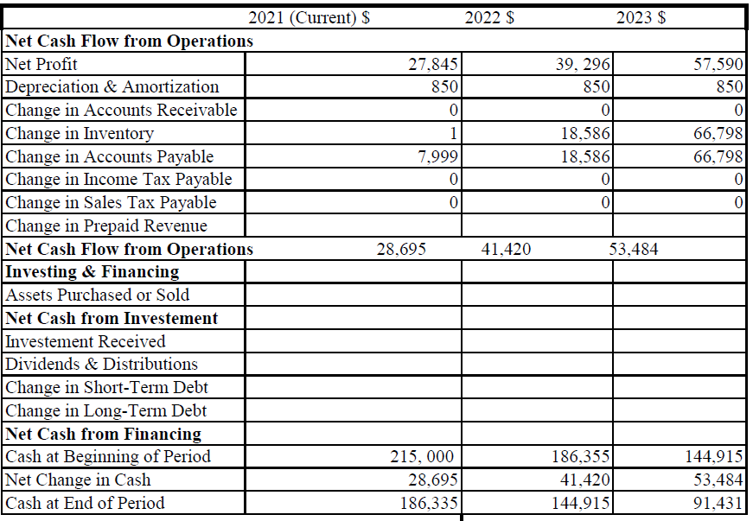
Figure 1
Pro Forma Balance Sheet
 | 2021 (Current) $ (000 | 2022 $ (000) | 2023 $ (000)
Assets
Current Assets
Checking Acct. | 13 | 16 | 19
Savings Acct. | 35 | 41 | 45
Accounts Receivable | 4 | 2 | 2
Inventory | 14 | 17 | 21
Total Current Assets | 66 | 76 | 87
Non-Current Assets
Plant and Equipment | 14 | 14 | 14
Delivery truck | 9 | 9 | 9
Total Non-Current Assets | 23 | 23 | 23
Total Assetss | 89 | 99 | 110
Liabilities & Equity
Current Liabilities
Account Payable | 10 | 9 | 11
Line of Credit | 21 | 19 | 18
Total Current Liabilities | 31 | 28 | 29
Non-Current Liabilities
Loan | 215 | 105 | 50
Total Liabilities | 218 | 133 | 79
Equity
Owner's Capital | 35 | 35 | 35
Retained Earnings | 45 | 56 | 65
Total Equity | 80 | 91 | 100
Total Liabilities & Equity | 295 | 224 | 179
Table 2
Break Even Analysis
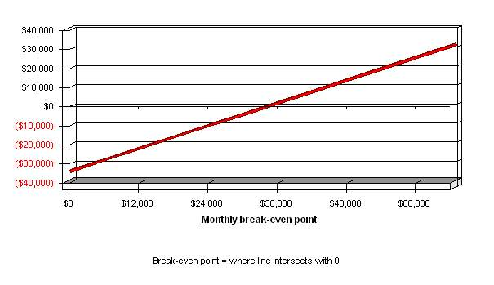
Figure 2

Revenue Break-even (monthly) $34,254
Assumptions:
Variable Cost (average) 53 percent
Estimated Fixed Cost (monthly) $34,072
Table 3
Sources of Funds and Application
The primary source of funds will be the three entrepreneurs, Adams J. Joseph
Glidden Jason, and Mr. Jurenka David who form our board of directors. The funds will be used to set up the initial infrastructure that is required to run the business.

References
Alwon, B. M., Solomon, G., Hussain, F., & Wright, D. J. (2015). A Detailed Analysis of Online Pharmacy Characteristics to Inform Safe Usage by Patients. International Journal of Clinical Pharmacy, 37(1), 148-158.
Prashanti, G., Sravani, S., & Noorie, S. (2017). A Review on Online Pharmacy. IOSR Journal of Pharmacy and Biological Sciences, 12(3), 32-34.
Sabbir, M. M., Islam, M., & Das, S. (2020). Understanding the Determinants of Online Pharmacy Adoption: A Two-Staged SEM-Neural Network Analysis Approach. Journal of Science and Technology Policy Management.
Van Der Nat, D. J., Taks, M., Huiskes, V. J., Van Den Bemt, B. J., & Van Onzenoort, H. A. (2021). A Comparison Between Medication Reconciliation By A Pharmacy Technician And The Use Of An Online Personal Health Record By Patients For Identifying Medication Discrepancies In Patients’ Drug Lists Prior To Elective Admissions. International Journal of Medical Informatics, 147, 104370.

Appendix
Market research data
A survey completed by 1055 outpatients in total with a response rate of 77.23%, an average age of 45, over 456 people 43.22% said they had chronic health problems. Although most of the respondents (872/1055, or 82.65%) were aware that pharmaceuticals could be purchased online, only 44, a percentage of 4.17%, had done so in the past. Respondents recognized retail pharmacy units as the most acceptable drug source while rejecting internet pharmacies, indicating significant variations in attitudes toward the various pharmaceutical supply chain retail channels. Respondents were asked to rate nine statements on the potential benefits and drawbacks of buying medicine online. The calculated relative attitude rate shows a slight but significant tendency toward rejection. The correlation between demographic characteristics, internet usage behavior, and potential online drug purchase attitudes was assessed. Respondents who spend more time on the internet and buy products online are more inclined to buy drugs online. Furthermore, the purchasing behavior of medications will be influenced by youth and education.
Letter
To our esteemed clients,
Are you looking for a quick and easy way to get your prescriptions? We guarantee that you will receive your item the same day! There is no need to stress about going to the doctor and paying exorbitant expenses. There is no need to be concerned about embarrassment-inducing gifts because we vow to keep everything private. Check out the most acceptable deals we have for you: * (cheap costs and best-selling list prescriptions) Get your medication from one of the most remarkable online pharmacies? That is who we are! Guaranteed to be hassle-free and delivered on schedule.
Sincerely,
E-Pharmacy.
Price List from Supplier
